Revelation Chapter 6
In this chapter we find ourselves in a continuation of the Lamb in the throne room. We get the impression that after the Lamb is worshiped for being able to take the scroll, He takes no delay in beginning to break the seals. Although we do not hear about the throne any longer in this chapter we are presented with an altar (v.9) that we would presume to be in the proximity and presence of the one on the throne. We also have the same four living creatures present as well so we understand that we have not moved far from the throne room in time or space. We will look at each seal in more detail but we see immediately that the opening of these seals brings great pain and heartache to the earth. It is one of the most important topics to settle as we look at chapter 6 from the perspective of God’s people. We must determine how to faithfully think about and handle the wrath of the Lamb (v.16) The first four seals are ushering in the appearance of the four horsemen of the apocalypse and the doom and destruction that follows after them. In the late 15th century Albrecht Durer captured one of the most memorable and earliest portraits of these horses and their riders. These horsemen and the judgments which they bring are well known and documented. The difficult part for us as Christians is that we have to wrestle with the fact that it is the Lamb of God who is opening the seals and ushering in these horsemen and their activity. It is appropriate for us then to ask - why God breaks the seals and releases His wrath on the earth? I think there are three primary reasons for this to remember as we soberly digest the devastation of these seals. #1 God releases judgment on the earth to purify His bride and to provide for their salvation. #2 God releases judgment on the earth to bring justice and to execute wrath upon His enemies. #3 God releases judgment on the earth to cleanse it and ultimately end Satan’s influence on the world. In addition to these primary reasons you could also add His faithfulness to fulfill His promises to do so and to glorify His own name in the process but these could be said of any action that God takes. God intentionally and purposefully releases judgment on the earth for the benefit of His people, for the detriment of the devil, and for the purification of the earth and the arrival of the New Jerusalem. For a summary chart of the Seals, Trumpets, and Bowls see here pjHHZ.png (2389×1775) (sstatic.net)
We are also reminded that the glory of the throne room should be in the forefront of our minds as we talk about the Seals, Trumpets, and Bowls. There is only one who is on the throne forever and ever and there is only one who is worthy to take the scroll and open its seals. Therefore, anything that this Lamb and His Father conduct we trust implicitly and understand their authority to do so. As followers of Jesus Christ who have prayed the Lord’s Prayer a countless number of times, we need to understand that these events are the culmination to our prayers for God’s Kingdom to come. As Martin Luther once taught us - that this is to place all that opposes our God’s dominion into a pile and pray: “Curses, maledictions, and disgrace upon every other name and every other kingdom. May they be ruined and torn apart, and may all their schemes and wisdom and plans run aground” (Luther’s Works [1956], 21:101). “Thy kingdom come” is the positive way of praying, “Destroy every other kingdom that resists your will or stands in your way.”
Another significant topic to explore in this chapter is the order of all of the judgments that are released on the earth. There are a total of 21 judgments with three groups of seven judgments each. There are seven Seal Judgments, seven Trumpet Judgments, and seven Bowl Judgments described in the book of Revelation. The interesting thing about the different groups is that some of the seals, trumpets, and bowls sound very similar to each other and some are dissimilar. Therefore there have been three different primary interpretations of their relationship to each other as far as timing is concerned. See the chart below for a visual of the differences. The first one is the Sequential or Successive interpretation which sees that the Seal Judgments happen first followed by the Trumpet Judgments and then finally the Bowl Judgments. This is the way that they happen numerically in the book of Revelation (Chapter 6 Seals, Chapter 8 Trumpets, Chapter 16 Bowls) and without further examination it would appear to be the natural occurrence. But after closer examination you can see that the 7th judgment in each group sounds identical to each other and so another interpretation became prominent called Simultaneous where there is overlap for all seven of the Seals with the Trumpets and the Bowls. So that you can understand the complexity of this perception about the 7th judgments being the same event let me share the Scripture verses for each group. The seventh Seal from Revelation 8:5 “Then the angel took the censer and filled it with fire from the altar and threw it on the earth, and there were peals of thunder, rumblings, flashes of lightning, and an earthquake.” The seventh Trumpet from Revelation 11:19 “Then God’s temple in heaven was opened, and the ark of his covenant was seen within his temple. There were flashes of lightning, rumblings, peals of thunder, an earthquake, and heavy hail.” The seventh Bowl from Revelation 16:18 “And there were flashes of lightning, rumblings, peals of thunder, and a great earthquake such as there had never been since man was on the earth, so great was that earthquake.” It appears clear that these events are one in the same but the other numbers do not share the same consistency or commonalities. Therefore, another interpretation has arisen which combines these two understandings which I will call “Symbiotic”. The Symbiotic interpretation starts with the premise that the seventh judgments are the same event and that the chronology begins with the Seals. There are different variations of this Symbiotic interpretation but basically it would understand that the 21 judgments transpire in a relative order of 5 Seals then 6 trumpets then 6 bowls followed by the 6th Seal and then the 7th Seal, Trumpet, and Bowl happening simultaneously. This is an article which may provide more helpful information on this subject. What is the chronology of Revelation? Do the seals trumpets and bowls overlap? (jesusplusnothing.com)
One thing for us to remember as we discuss the placement historically or prophetically of these judgments is that the emphasis in Scripture is not on their timing. Jesus indicates that we should be aware of the times and recognize the seasons but we are reminded that no one knows the day or the hour. Jesus’ emphasis in the Olivet discourse in Matthew 24-25 is on the hiddenness of His coming so that we are ready at any time and will have the patient endurance that is required by His people during such times. If we were supposed to answer this question about the order of the judgments and their occurrences in a certain and decisive manner it would be much clearer. Instead of worrying about which judgment is next worship the Lamb, trim your lamps, and continue to use your talents for the kingdom of God until He returns.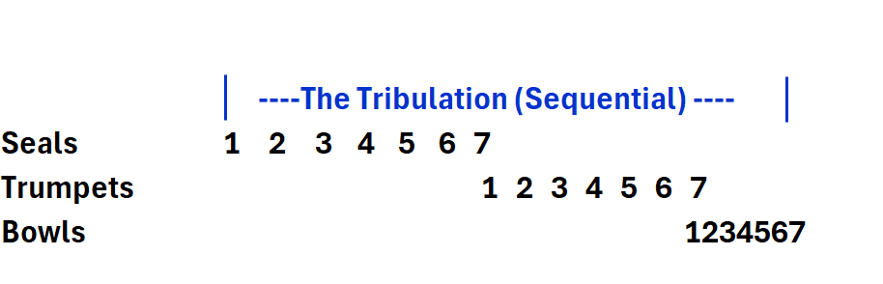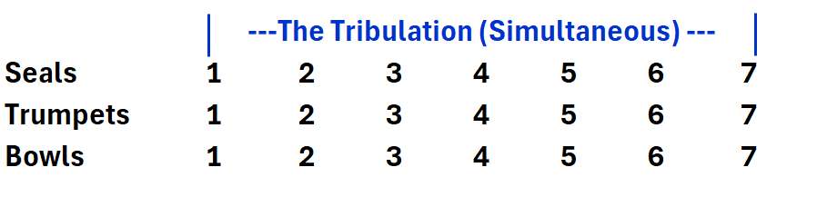

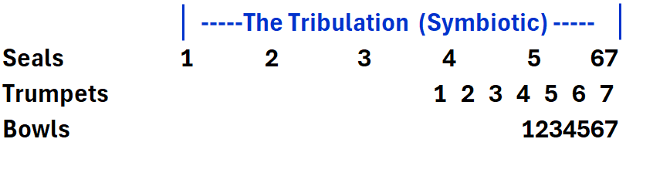
V.1-7 Four Seals Each of the first four seals are described in the exact same manner with different horses and consequences which follow. The first horse is white, the second horse is red, the third horse is black, and the fourth horse is pale green. Each horse has a rider and each horse is beckoned by one of the four living creatures that surround the throne. It appears that each of the horses progresses in its severity with each seal. This is the general pattern of all the judgments which become more severe as consequential judgments are released. The most controversial horse in its interpretation is the first horse because it is white in color. Typically, in Scripture and in the history of the world white is an indication of purity and goodness but in this scenario, we suspect that this is not the case. Some have suggested that this may even be Jesus himself since we see Jesus riding a white horse when He returns to the earth in Chapter 19. This interpretation is not likely though for two obvious reasons. One reason being that it is the Lamb of God that is opening the seals and although there is symbolic language throughout the book, we see John distinguish who he is talking to and how he is interacting with them. It would certainly be odd for the Lamb to open the seal then get on the first horse and be back to open the second seal. The other reason that it is unlikely to be Christ is because this individual has come out “conquering and to conquer”. And although we certainly see the exalted Christ conquering in the book of Revelation we don’t expect to see it at this point with the other deadly horses and their riders. The two most plausible explanations that have been proposed for this figure on the white horse are the Antichrist or a general picture of “Tyranny” being described as going out to wreak havoc and devastation. The second horse is red with a rider that is permitted to take peace from the earth and he was given a great sword. This typifies war and violence that is ushered in by this horse. The third horse is black and his rider is described as having a pair of scales in his hand. This horse and his rider bring forth financial devastation where the ability to buy food becomes scarce and immensely expensive. The fourth and final horse is pale or green and is typifying the color of those who are severely ill or dead. The rider’s name is Death and following closely behind him is Hades. They are given authority to take life on a fourth of the earth.
V.9-11 The Fifth Seal The opening of the fifth seal is the only judgment of its kind that we see throughout all twenty one occurrences. In this scenario there is a group of souls that John sees under the altar who had been martyred. He hears them ask “O Sovereign Lord, holy and true, how long before you will judge and avenge our blood on those who dwell on the earth?” John says that they were each given a white robe and told to rest a little longer until their fellow servants are killed as they had been. There are many different interpretations of these verses but the most probable is that this seal is an unleashing of martyrdom on the earth. If you are in the camp that believes the rapture has already transpired then you are forced to believe that these martyrs have been converted from those who were left after said rapture. If you don’t believe in the pre tribulation rapture then this could certainly be the beginning of the period that Jesus talks about in Matthew 24:9-10 “Then they will deliver you up to tribulation and put you to death, and you will be hated by all nations for my name’s sake. And then many will fall away and betray one another and hate one another.” This is a natural location for this possibility since the first four seals have released devastation and destruction upon the earth. The natural response of the people of earth to such conditions will be persecution upon the church. This would be very similar to what happened to the Jewish people during the bubonic plague. Because of their stricter food and grooming laws the Jews were not as apt to catch and die from the plague and they were often blamed for it consequently. The pattern will likely be something similar to what Jesus describes which begins with tribulation on the earth both by man and acts of God which will cause fear and anger among those who are not part of God’s kingdom. This will lead to persecution and martyrdom which will cause God’s increasingly severe response which will create the scenario of those who choose to side with the man of lawlessness and those who remain with God being captured or killed. In very similar ways this is the story of the Exodus where God said let my people go and I take this to be the beginning of such a pattern with the opening of the fifth seal.
V.12-17 The Sixth Seal The sixth seal by all accounts appears to be so comprehensive that it is the end of the world as we know it. Whatever cataclysmic event transpires it affects the sun, moon, and stars. The text says that the sky vanished and every mountain and island was moved. It is so bad that every person on the earth hides themselves in caves and mountains. Due to the severity of this Seal Judgment it is probable that the Seals, Trumpets, and Bowls are not completely sequential because by the sounds of this description there is very little left after this event on the earth. But we also should not presume that this is just symbolic or apocalyptic language because we see Jesus describe the event with almost exactly the same language. “Immediately after the tribulation of those days the sun will be darkened, and the moon will not give its light, and the stars will fall from heaven, and the powers of the heavens will be shaken.” (Matthew 24:29) There is also similar language in Joel 2:10 and Isaiah 34:4. This event will happen. It is just a question of when and who will still be here?
This devastation is a reminder to us all that this is one of the primary purposes of Revelation - to help us settle in our hearts that no matter how bad the conditions or even the prospects of death and martyrdom, we are to remain faithful to the end. I am reminded of the saying - don’t sell your soul to live like a prince today when you can wait and live like a king forever. We just finished looking at the throne room in heaven in chapters 4 & 5 lest we forget the relevance of confirming our eternal destinies as God’s children no matter what the cost. There will come a point that it will not be well on the earth but we still have the opportunity to confess that it is well with our soul as we see in verse 4 of this great hymn.
And Lord haste the day
When the faith shall be sight
The clouds be rolled back as a scroll
The trump shall resound
And the Lord shall descend
Even so it is well
With my soul

